

Contents
Index of Tables 2
Summary 3
Status 3
1 Introduction 4
1.1 Taxonomy Ownership 4
1.2 Objectives of This Document 5
2 Business Requirements. 5
2.1 Flexibility/Extensibility 5
2.2 Stability 5
2.3 Ease of Implementation 6
3 Differences from the Previous Version 6
4 Summary of Known Limitations and Restrictions 6
5 Taxonomy Structure 6
5.1 Modularisation 7
5.2 Blocks of Information Using Tuples. 9
Concept Value Lists 10
5.3 Code List Modularity 13
5.4 Dimensions 16
5.5 Element-Naming Conventions 16
6 Summary of the Guide on Introduction and Use of the Taxonomy 17
7 Summary of Problems Encountered 17
7.1 Problem in Establishing a Common Dictionary of Concepts for Different Institutions 17
7.2 Problem in the Contents of Each Module 17
8 Approval Process 19
9 Test Sets Run 20
10 Copyright. 24
11 Thanks. 24
12 Document Management 24
Table 1. Specific Terminology of the Taxonomy 25
Table 2. Specific Content. Data Dictionary 27

Index of Tables
Table 1. Specific Terminology of the Taxonomy 25
Table 2. Specific Content. Data Dictionary 28

DGI (General Identification Data)
Summary Document
Final Document Version 2.1 date 27-04-2006

Summary
This document summarizes the information concerning the DGI taxonomy, which belongs to Asociación XBRL España.

Status
This is a final taxonomy presentation document.

Introduction
The DGI taxonomy (‘DGI’ being the abbreviation of ‘Datos Generales de Identificación’ or ‘General Identification Data’) has been promoted by the leading official Spanish organizations (the Bank of Spain, the Association of Registrars, the National Securities Market Commission, the Tax Agency, the National Statistics Institute) and a number of the major Spanish companies involved in the processing of general company data from the standpoints of taxonomy management tool production (Fujitsu), XBRL solution design (PriceWaterhouseCoopers, Software AG, Soluziona) and business database operation (Informa).
Framework of Application and Expected Use of the Taxonomy
To facilitate the general identification data of the entities that send in XBRL reports, in response to needs for public information (under the rules set by regulating organizations) and private information, thus enabling the trading of financial information as an aid in business decision-making.
The main object of the taxonomy is twofold: One, to report non-financial business information identifying entities using a varied range of information, and two, to report documentation information on the XBRL report itself, such as who wrote the document. Therefore the taxonomy is defined as a data dictionary that can be used to construct XBRL reports expressing information to report information that reflects the identification structures of companies and presented documents.
The identification information of companies is varied in nature, because it has to be equally able to describe a business group or a business company, an individual enterprise or a self-employed businessperson. Depending on individual cases, this information may be enriched by the possibility of adding other, additional structured information, which has also been defined.
This variety of structure types means that the taxonomy is a general-purpose taxonomy. It provides the definition of the information structures, and those blocks that are necessary in each type of report may be selected from among the information structures.
The future use of the DGI taxonomy pursues a two-pronged objective: to be used in itself as a source of general entity information and to be used as a necessary complement to any other taxonomies that are developed (PGC90, IPP-CNMV, etc.).

Taxonomy Ownership
© This taxonomy was created by the DGI taxonomy subgroup of Asociación XBRL España, an association for the dissemination of technology standards, under the mandate of the Asociación XBRL España taxonomy group.

Objectives of This Document
The objectives of this document are:
- To explain the creation process and the resulting structure of the DGI taxonomy.
- To present the differences with respect to the previous version.
- To present the results of the test sets.
- Technical problems encountered in developing the taxonomy and solutions found.
- To present the full contents of the elements of the taxonomy.
- Current situation of taxonomy development and pending issues.

Business Requirements.
This taxonomy is based on compliance with the following business requirements:
2.1 Flexibility/Extensibility
2.2 Stability
2.3 Time Frame
2.4 Ease of Implementation

Flexibility/Extensibility
The DGI taxonomy has been designed to include a sufficiently ample number of entity-identifying data elements to cover the general needs of each XBRL report, regardless of a report’s specific realm of application. This design is to facilitate the subsequent development of all extensions of this taxonomy that prove necessary, especially where regulators are concerned.
With respect to policies on extending taxonomies from the DGI taxonomy, consistency must be guaranteed between the general or ‘parent’ taxonomy and the extensions, such that the structure of common blocks of information is preserved and the newly created or ‘extended’ elements are guaranteed not to enclose any contradictions or duplications.
Competence for approving national extensions will belong to the DGI working subgroup. Private extensions fall outside this approval process.

Stability

Once the definitive version of this taxonomy is published, it is recommended to refrain from changing it for at least one year. The point of so doing is to lend each version stability, thus facilitating the work of taxonomy users, because the taxonomy is employed as an informative complement of the other taxonomies. This period could be shorter in exceptional cases for significant changes requiring a new version of the taxonomy due to legal imperative, adjustment to requirements received from XBRL International (especially in extensions of international taxonomies) or majority requests from users.

Ease of Implementation
The modular structure of this version, which is discussed in section 5 of this document, makes this taxonomy easier to use, achieving effective time savings in downloading and the XBRL report validation process, because it allows users to select what modules they need at the time.

Differences from the Previous Version
The fundamental variations with respect to the previous version of the taxonomy are dictated by the way the data dictionary is structured in modules. The specific details of the changes can be seen in one of the separate documents attached to the taxonomy.

Summary of Known Limitations and Restrictions
This taxonomy does not implement particular identifiers for each XBRL report presented. It merely identifies the type of report being presented. The specific identifier for each XBRL report presented must appear in the proper extension of the DGI taxonomy.
Example: A report presented to the Tax Agency (AEAT) concerning corporate income tax, form 200. The particular reference or references of the form (for example, the bar code printed on that particular form) will only appear in the DGI extension created by the AEAT.

Taxonomy Structure
This chapter describes the structure of the General Identification Data taxonomy based on XBRL specification 2.1 and reports on the technical problems encountered during development and the proposed solutions.

The main portion of the chapter describes the design principles used to put together the dictionary of data identifying the entities and their associated information and identifying the additional identification information of an XBRL report, such as the report’s author. Because this is a general-purpose taxonomy, an explanation is also given of the design intention to facilitate use of the taxonomy and extension into other taxonomies.

Modularisation

Responding to the user complaint that there were too many elements available in the first version of the DGI taxonomy, this version has been structured into different modules that can be used separately to suit the requirements of each XBRL report presented.

The modules’ structure is based on clustering by content. Where content so requires, modules are also clustered into basic or extended modules.

The modules are structured as follows:

- General Data (3 modules):

Elementary. General data in a minimal structure.

Basic. Sufficient elements for a normal presentation.

Extended. Containing all the General Data elements.

- Economic Activity (2 modules):

Basic. Transactions, main activities and employees.

Extended. Basic content plus information on local units.

- Ownership Structure/Third-Party Relations/Corporate Organ.

- Presented XBRL Report. Data on the author, presenter and document type.

- General Purpose Structure (tuples). Clustered structures of elements that can be reused in different modules.

- Concept value list modules.

- Data type module, created for technical reasons to manage the code lists used in DGI.

For a more detailed grasp of the content of each of the modules, see table 2 of the appendix to this document.

Technically, these modules will be represented by means of the following types of taxonomies:

- Primary Taxonomies: These are the taxonomies that coincide with the general-data modules mentioned above. The user has to choose between using the elementary taxonomy, the basic taxonomy or the extended taxonomy. The elementary taxonomy is fully autonomous and imports no other modules, while the extended taxonomy imports the basic taxonomy; and both the basic and the extended taxonomies make use of the auxiliary taxonomies, to reuse the general structures.
- Complementary Taxonomies: These are the taxonomies modelling the rest of the business information that has been left out of the general-data modules. Users will make use of whatever information they require.
- Auxiliary Taxonomies: These are taxonomies that will be created to cover technical needs, such as the taxonomy of data types or general structures.
- Code Lists: Taxonomies created to define the elements that will comprise the code lists to be used. As many code list taxonomies as considered necessary will be created, although there will be three to start with:
- National List Taxonomy.
- International List Taxonomy.
- Activity Code List Taxonomy.

We can see a graphic depiction of how these taxonomies would be classified in the following figure.

Fig. 5.1.: Modular Structure of the Taxonomy

Blocks of Information Using Tuples.
Business information is compiled on the basis of blocks of information that are defined in XBRL by tuples. This means that a data model is constructed by grouping those concepts of the reports that must be reported jointly in order for the information to make sense, and that are likely to be repeated jointly in the same report.
Let us take the example of a company’s contact people: The contact person can be reported as a block of information containing, for example, the person’s given name, paternal surname and maternal surname. Furthermore, wherever these three fields must appear in the report, they must be filled in together, not separately. Therefore these three fields are taxonomy concepts that must be defined in a block, which contains them. In XBRL language syntax, this block is the ‘tuple’ Name (Individual), containing three elements or ‘items’ (given name, surname1 and surname2).
Once we have analysed all the blocks of information to be defined in the DGI taxonomy and understood how to construct the information so that it cannot be split up and can be repeated in block form with XBRL, we proceed to classify the blocks as one of two general types, simple blocks or compound blocks, the latter of which will contain other simple blocks.
One example of a simple block is the tuple Name (Individual) that we saw in the example above. Another simple tuple is the tuple Identifier type.
One example of a compound block might be the tuple Legal name, which contains, for example, one tuple for the type of legal name the entity has, a separate tuple for the status and then two items, one for the value of the name and one item with the date of the last change of name.
To conclude this definition, we may say that in XBRL complex structures are designed using tuples that contain other, nested tuples that are simpler blocks. Simple blocks may be reused within the different compound blocks.
For example, in a report where a company is identified, we want to report information about the contact people, which includes the name and address of the person, and we are also going to report information on the company’s branches, stating the name of each branch and its address.
Therefore, we design a simple address tuple, which is reused in the complex tuple Contact Person and also in the compound tuple Company Branches (also termed Local Units).

Concept Value Lists

Reasoning

Within the information in the data dictionary, certain concepts are identified for which in the report there is only a single possible value from among a discrete list of predefined, encoded values. For example, for the identification of companies, any report that wishes to indicate the legal form of a company must report a particular value from among those previously defined on a list of available legal forms (Corporation, Limited Liability Company, etc.).

Within the business group, value lists are, for company information reporting, a way of expressing concepts with univocal semantics and reducing the possibility of errors in the generation of XBRL reports, because value lists facilitate the range of possible values to be filled in for a given concept.

List Design in XBRL

The design of the DGI taxonomy for defining value lists is based on the following principles of XBRL specification 2.1:

- Several types of tuples may be defined (All, Sequence, Choice).
Choice: Where one element may be selected from among several available elements.
Sequence: This property means the items the tuples contain comply with an order pre-established in the content model.
All: The elements may be in any order whatsoever, and there are no restrictions on choice.
- For value lists, the tuple will be a Choice tuple.
- In a taxonomy, types of data may be defined concerning the taxonomy itself. These data types are derived from the basic data types defined in the specification (String, Integer, Boolean, etc.).

- A tuple can define an abstract child.

- Any item can be replaced by a member of its substitution group, provided that both items have or are derived from the same data type.

Adhering to the requirements for expressing value lists and the principles described above, the mechanism for designing value lists consists in the following steps:

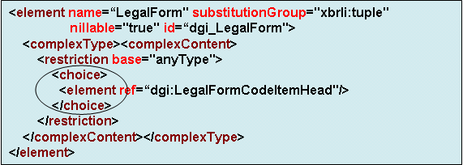
- The list is defined as a tuple in which the cardinality of its content consists of one element from among several available elements (choice tuple).

- Each element of this choice tuple is a concept from the dictionary (item) which indicates a value from that list (for example, Corporation is an Item in the Legal Forms tuple).

- For these elements (items) that represent each value on the list, a data type is defined that will be derived from the basic data types defined in XBRL 2.1, such that a code can be expressed for this value on the list.

For example: For the legal forms list, a data type is defined that is derived from String (text), which is termed TipoCódigoFormaLegal (LegalFormCodeType). This data type is a derivation from XBRL’s basic data type, StringItemType, and each item on the list. For example, Corporation is of the TipoCódigoFormaLegal type, whose code will be represented, for example, by 01 (two-position string).
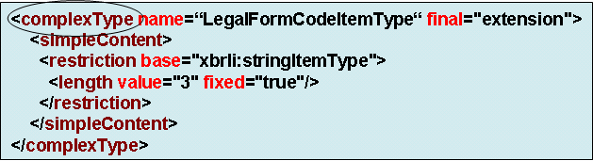
Value List Maintenance
The different possible values on each list may change over time (for example, a new type of legal form may be established); they therefore involve an additional maintenance task to be considered by the working group when defining the taxonomy.
In order to facilitate use of the taxonomy by providing value lists and preventing value maintenance from penalizing use of the taxonomy, first the data model lists were studied, applying a series of criteria that helped classify the lists according to their value definition sphere, value update frequency and maintenance responsibility. Two groups of lists were yielded as a result:
- Local or jurisdictional code lists
These are value lists where the responsibility for defining new values or changes of existing values supposedly belongs to organizations related exclusively with the XBRL jurisdiction for which the taxonomy is created. In the case of DGI, XBRL-España only would have jurisdiction.
These are time-stable lists whose values do not change often, such as Legal Form, etc.
International (Stable or Variable) code lists
These codes’ values have been defined by international organizations (ISO, SWIFT, UN, etc.). They may be divided by value update frequency into:
- Time-stable lists (Ex.: ISO 3166-2 for countries):
  - One copy of the international lists will be maintained in the taxonomy, until there is some other international organization that defines them and provides them in an XBRL taxonomy.
  - Maintenance includes only updating with the changes made at the international level by the responsible organization (ISO, etc.).
- Values that change very frequently (Ex.: SWIFT BIC for international identification of financial institutions): Only a reference to the list’s identifier is included in the taxonomy. Neither a copy of the values nor updates are maintained within the taxonomy.

Technically, we will create a taxonomy for each of these code list groups, although all the lists of significant size will be set in an independent taxonomy, to avoid overloading the taxonomy with code lists that we are not going to use. So, we are going to find the following taxonomies of code lists:
- dgi-lc-int-2006-01-09: Taxonomy for the lists of international codes that do not have their own taxonomy.
- dgi-lc-es-2006-01-09: Taxonomy for the lists of national codes that do not have their own taxonomy.
- dgi-lc-ac-2006-01-09: Taxonomy for the lists of activity codes.

Taxonomy Size
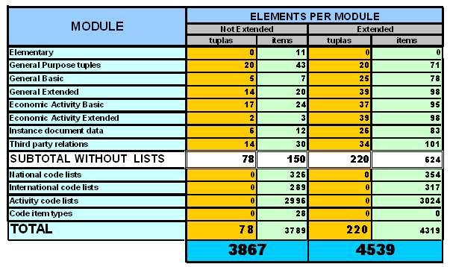

As can be seen in the chart above, the degree of element reuse through tuples is very high. For example, the number of elements directly used by the modules is 151 items and 82 tuples (not counting lists), while the inclusion of all the extended elements from the tuples in the different modules brings us to a total of 650 items and 232 tuples.
Taxonomy size: The nucleus or central body of the taxonomy consists in 150 elements and 81 tuples.
Special mention might be made of the use of the following linkbases:
- Calculation Linkbase. To incorporate the checks of the information referring to employment, located in the basic and extended economic activity modules.
- Reference Linkbase. The primary legal references of the elements whose nature demands such references have been described.
The taxonomy is FRTA-compliant according to the validations run with FUJITSU ver. 1.000 (0025) , TRUENORTH ver. 2.3 and UBMATRIX ver. 2.0.
The labels have been defined in Spanish and English. Labels in other languages spoken in Spain may also be created in future.

Code List Modularity
The modularity of the code lists is designed to provide flexibility between the data structures of the information blocks and the definition of the values from the different lists. Therefore, the following flow chart will be used to construct code lists. The chart shows how the taxonomy with the code list is imported into the taxonomy where that particular list must appear and the data type taxonomy:
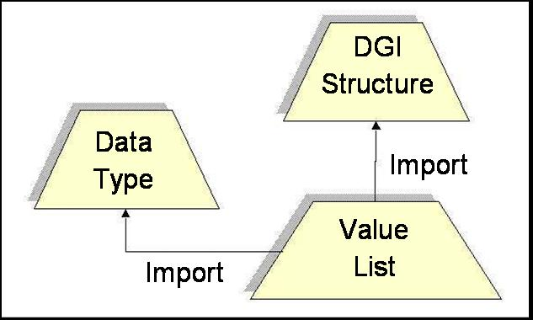

- Structure Taxonomy (any DGI module): This taxonomy contains the data dictionary with the blocks that define the structure of the information to be reported, simple tuples, compound tuples and data types of codes from the lists.
- Value List Taxonomy: This taxonomy contains the items the values on the code lists represent. For example, Legal Form, Province List, etc.
- Data Type Taxonomy: This taxonomy defines all the types of data we might need to create code lists.
Extensibility
The modular design explained above makes it possible to create taxonomies that add values to the lists defined by DGI. Let us take, for example, the list of communication types, where we can choose between post, e-mail, telephone, fax, etc., as values from the list. Let us now imagine a taxonomy for the internal reporting of a company’s human resources department, taking advantage of the taxonomy’s structure as an extension of DGI. The list of communication types could be expanded with a new value, for example, internal instant messaging.
Another extensible factor of the value lists is that each value on the list is an XBRL item, which means semantic information can be added to it by means of linkbases. For example, we can define several literal terms in different languages for a value on the code list.
Substitution Mechanism

When defining the structure of code lists in the DGI taxonomy, we need to use something to separate the structure and the values into two taxonomies. To do so we use the type substitution mechanism that the XBRL specification provides, on the basis of the recommendation of XMLSchema:

- First of all, we define a single child in DGI, for example, in the legal form tuple, which is an abstract tuple.

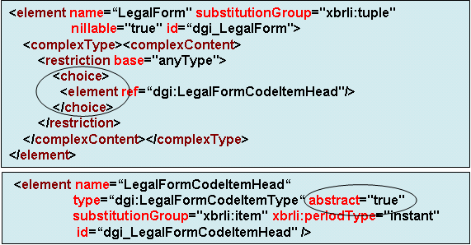
- We indicate that the substitution group for all the elements representing the values is this new element we have just defined, which we may term a list head. Thus, what we are indicating is that in the DGI taxonomy there is an information structure that is a choice-type tuple and contains elements of the LegalForm type, and we prepare the type, indicating an abstract child as the head. Lastly, in the DGI-LC-ES taxonomy we define all the items of the list as substitutes for this head. In order for the substitution to be performed correctly, the elements have to be of the same type or a parent type. We may also indicate the code value as a fixed tuple.
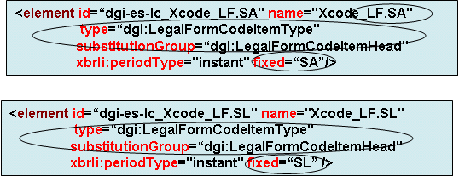
Additional multilingual and reference information is added in the linkbases of the DGI-LC-ES taxonomy, enriching the semantics of the values on the list:
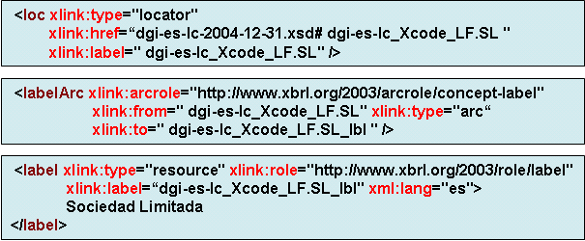
One consideration of this design is that the FRTA validation rules are not entirely applicable, because information is modelled on lists of values that are not financial elements.
One clear example of this is the mechanism for creating unique identifiers for the elements that define the values on the list. As they must be unique and they represent codes, so as not to create ambiguities the identifiers are defined as the concatenation of the taxonomy’s prefix, the Xcode identifier that distinguishes each identifier from the other items, the unique value from the list and the code of the element. Lastly, the XBRL report that reports these concepts that represent value lists will build the facts to be reported from among a series of discrete values from the list taxonomy, such as:

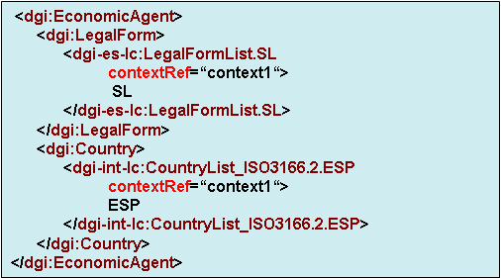

Dimensions
The working subgroup has not considered it appropriate to use dimensions in the development of the DGI taxonomy.

Element-Naming Conventions
The convention used is the L3C (Label CamelCase Concatenation) system, without punctuation marks. This complies with FRTA requirements.
The names of the elements on the code lists adhere to the following construction rule:
- ‘Xcode’ prefix
- Underscore ‘_’
- Three-letter acronym identifying the list it belongs to, ‘LST’
- Dot ‘.’
- Element value ‘VALOR’ free chain
Xcode_LST.VALOR
This style of naming the elements of code lists has been used in other working groups on international taxonomies, such as CRAS and GCD.
It is necessary to create a map for the characters not permitted in label names, because labels must be as descriptive as possible without violating the L3C (Label CamelCase Concatenation) system.

Summary of the Guide on Introduction and Use of the Taxonomy
On the 1st March 2006 the Spanish XBRL jurisdiction was presented with a first draft of the taxonomy known as dgi-2006-01-31. At that point a period of public consultation and revision by the technology group began, and it ended on the 31st March when the operational version was published.

The definitive taxonomy opens up the possibility of reporting information and identifying data of companies, persons and documents much more flexibly than with the first version of the taxonomy, which was published in 2005.

Summary of Problems Encountered
During the development of the DGI taxonomy, the working subgroup encountered a series of business problems when identifying the information structures that can be regarded as general-purpose and common to data dictionaries for the different organizations that need to identify individuals, companies, enterprises and documents. The problems encountered and solutions proposed are described below.

Problem in Establishing a Common Dictionary of Concepts for Different Institutions
- The organizations involved in the working subgroup, inter alia the Association of Registrars, the National Securities Market Commission, the National Statistics Institute, the Tax Agency, the Bank of Spain and Informa, initially pooled all the information each of them regarded as of interest for identifying entities.

- This initial dictionary constituted a highest common denominator of reporting concepts.

Most of the problems in the working subgroup consisted in setting limits on the taxonomy, between what information may be regarded as of general use by all institutions and what information is for the exclusive use of a particular organization.

The eventual technical solution consists in moving those concepts that are not for general application into local extensions of the taxonomy, which expand these information structures with said concepts.

Problem in the Contents of Each Module

- The modularisation of the taxonomy made for some difficulties in detailing the exact contents of each module, due to the lack of a predefined legal or formal schema. It was also necessary to reconcile different points of view about assigning elements to one module or another depending on the characteristics of each element.
  - Problem of Value List Maintenance

The responsibility of maintaining the value lists arose as a potential problem during the identification of the code lists.

A solution was proposed, consisting in dividing the DGI taxonomy into several taxonomy modules, thus isolating the maintenance of the concept structure from the maintenance of the actual values on the lists, as commented upon in detail in section 5.3 discussing the taxonomy’s structure.

Approval Process

 | Status | Decision Taker | Next Step | Required Revisions | Target Date
1 | Internal draft of the taxonomy | Taxonomy Subgroup Head |  |  | 2006-02-15
2 | Publishing of the draft at XBRL España, 30-day commentary period | Chairman of the Strategy Committee |  |  | 2006-03-01
3 | Revision of the draft by the Technology Group | Technology Group Head |  |  | 2006-04-12
4 | Approval of the definitive taxonomy by the Taxonomy Group | Taxonomy Group Head |  |  | 2006-04-27
5 | Publishing of the definitive document at XBRL España | Secretary XBRL España |  |  | 2006-04-28
6 | Publishing at XBRL International | Secretary XBRL España |  |  | 2006-05-12

Test Sets Run
Test sets were run with 17 real documents provided by the members of the working subgroup. This helped improve the current version of the DGI taxonomy.
The full report is in one of the separate documents accompanying the taxonomy.

XBRL Test Reports.

- Case list.

The XBRL-DGI Subgroup conducted a series of test cases related with different spheres in which the business agents move. These test cases were adapted to the modularisation performed with respect to version dgi-2005-06-30.

  - CNMV (National Securities Market Commission):
    - GESTORA DE PRUEBAS-gen-bas.xml : Report referring to the Basic General module.
    - GESTORA DE PRUEBAS-rel.xml: Report referring to the third-party relations and corporate organ module.
    - SOCIEDAD DE PRUEBAS-eco-ex.xml: Report referring to the extended economic activity module, which in turn will need the extended economic module.
    - SOCIEDAD DE PRUEBAS-gen-ex.xml: Report referring to the extended general module and also using the basic general module.

  - Bank of Spain:
    - EMPRESA DE PRUEBA 1-dat-inf.xml: Report referring to the presented report data module.
    - EMPRESA DE PRUEBA 1-eco-bas.xml: Report referring to the basic economic activity module.
    - EMPRESA DE PRUEBA 1-gen-ex.xml: Report referring to the extended general module and also using the basic general module.
    - EMPRESA DE PRUEBA 1-rel.xml: Report referring to the third-party relations and corporate organ module.
    - EMPRESA DE PRUEBA 2-dat-inf.xml: Report referring to the presented report data module.
    - EMPRESA DE PRUEBA 2-eco-bas.xml: Report referring to the basic economic activity module.
    - EMPRESA DE PRUEBA 2-gen-ex.xml: Report referring to the extended general module and also using the basic general module.
    - EMPRESA DE PRUEBA 2-rel.xml: Report referring to the third-party relations and corporate organ module.

  - Mercantile Registries:
    - ABREVIADA_gen-ex.xml: Report referring to the extended general module and also using the basic general module.
    - ABREVIADA_INFORMACIÓN_MERCANTIL-dat-inf.xml: Report referring to the presented report data module.
    - ABREVIADA_INFORMACIÓN_MERCANTIL-gen-ex.xml: Report referring to the extended general module and also using the basic general module.
    - ABREVIADA_INFORMACIÓN_MERCANTIL-rel.xml: Report referring to the third-party relations and corporate organ module.
    - ABREVIADA-dat-inf.xml: Report referring to the presented report data module.
    - ABREVIADA-eco-bas.xml Report referring to the basic economic activity module.
    - ABREVIADA-rel.xml: Report referring to the third-party relations and corporate organ module.
    - CONSOLIDADA-dat-inf.xml: Report referring to the presented report data module.
    - CONSOLIDADA-eco-bas.xml: Report referring to the basic economic activity module.
    - CONSOLIDADA-gen-ex.xml: Report referring to the extended general module and also using the basic general module.
    - CONSOLIDADA-rel.xml: Report referring to the third-party relations and corporate organ module.
    - NORMAL_INFORMACIÓN_MERCANTIL-dat-inf.xml: Report referring to the presented report data module.
    - NORMAL_INFORMACIÓN_MERCANTIL-gen-ex.xml: Report referring to the extended general module and also using the basic general module.
    - NORMAL_INFORMACIÓN_MERCANTIL-rel.xml: Report referring to the third-party relations and corporate organ module.
    - NORMAL-dat-inf.xml: Report referring to the presented report data module.
    - NORMAL-gen-ex.xml: Report referring to the extended general module and also using the basic general module.
    - NORMAL-rel.xml: Report referring to the third-party relations and corporate organ module.
    - NOTA_CONSOLIDADA-dat-inf.xml: Report referring to the presented report data module.
    - NOTA_CONSOLIDADA-gen-bas.xml: Report referring to the basic general module.
    - NOTA_CONSOLIDADA-rel.xml: Report referring to the third-party relations and corporate organ module.

  - Informa:
    - Short.

      - primero_ECO-BAS.xbrl: Report referring to the basic economic activity module.
      - primero_GEN-EX.xbrl: Report referring to the extended general module and also using the basic general module.
      - primero_REL.xbrl: Report referring to the third-party relations and corporate organ module.
      - segunda_ECO-BAS.xbrl: Report referring to the basic economic activity module.
      - segunda_GEN-EX.xbrl: Report referring to the extended general module and also using the basic general module.
      - segunda_REL.xbrl: Report referring to the third-party relations and corporate organ module.
      - tercera_DAT-INF.xbrl: Report referring to the presented report data module.
      - tercera_ECO-BAS.xbrl: Report referring to the basic economic activity module.
      - tercera_GEN-EX.xbrl: Report referring to the extended general module and also using the basic general module.
      - tercera_REL.xbrl: Report referring to the third-party relations and corporate organ module.

    - Long.
      - primera_ECO-BAS.xbrl: Report referring to the basic economic activity module.
      - primera_GEN-EX.xbrl: Report referring to the extended general module and also using the basic general module.
      - primera_REL.xbrl: Report referring to the third-party relations and corporate organ module.
      - segunda_ECO-BAS.xbrl: Report referring to the basic economic activity module.
      - segunda_GEN-EX.xbrl: Report referring to the extended general module and also using the basic general module
      - segunda_REL.xbrl: Report referring to the third-party relations and corporate organ module.
      - tercera_ECO-BAS.xbrl: Report referring to the basic economic activity module.
      - tercera_GEN-EX.xbrl: Report referring to the extended general module and also using the basic general module.
      - tercera_REL.xbrl: Report referring to the third-party relations and corporate organ module.
      - cuarta_ECO-BAS.xbrl: Report referring to the basic economic activity module.
      - cuarta_GEN-EX.xbrl: Report referring to the extended general module and also using the basic general module.
      - cuarta_REL.xbrl: Report referring to the third-party relations and corporate organ module.

    - Mixed.
      - primera_ECO-BAS.xbrl: Report referring to the basic economic activity module.
      - primera_GEN-EX.xbrl: Report referring to the extended general module and also using the basic general module.
      - primera_REL.xbrl: Report referring to the third-party relations and corporate organ module.
      - segunda_DAT-INF.xbrl: Report referring to the presented report data module.
      - segunda_ECO-BAS.xbrl: Report referring to the basic economic activity module.
      - segunda_GEN-EX.xbrl: Report referring to the extended general module and also using the basic general module.
      - segunda_REL.xbrl: Report referring to the third-party relations and corporate organ module.
      - tercera_ECO-BAS.xbrl: Report referring to the basic economic activity module.
      - tercera_GEN-EX.xbrl: Report referring to the extended general module and also using the basic general module.
      - tercera_REL.xbrl: Report referring to the third-party relations and corporate organ module.

NOTE: To see the examples mentioned above, go to Asociación XBRL España’s website.

http://www.xbrl.org.es/informacion/dgi.html.

Copyright.
© Asociación XBRL España for the dissemination of technology standards.

Thanks.
This document would never have seen the light of day if not for the decisive contributions of the following people:

Name | Entity | Name | Entity
Jorge Salazar | Association of Registrars | José Meléndez | Association of Registrars
Pablo Navarro | Software AG | Francisco Javier Cobo | Software AG
Emilio Querol | PriceWaterhouseCoopers | Victor Pérez Villar
Luis Bourgon | Informa | Javier Terrón | Informa
José Ramón Zuazua | National Securities Market Commission | José Manuel Alonso | National Securities Market Commission
Gervasio Luis Fernández-Trasobares | National Statistics Institute | Esteban Barbado | National Statistics Institute
José Ramón Cano | Bank of Spain | Fernando Alonso | Tax Agency
Fabián González Reguero | Soluziona | Amelia  Escobedo | Association of Registrars

Document Management

2005-03-10 | DGI Taxonomy Subgroup | Version 1.0
2006-03-06 | DGI Taxonomy Subgroup (Draft) | Version 2.0

Table 1. Specific Terminology of the Taxonomy
Some terms used by XBRL may sometimes coincide with the terminology of other disciplines.

Table 1. Terminology Used in This Document.

Concept | Definition
CodeList | Lists of codes used to make data entry easier for the user, since he/she will only have to choose one value from among the possible values. We followed FLIPA methodology when defining the code lists.
Context | Context forms part of XBRL Reports, and it is used for each datum or value indicated in its particular context. Every datum must belong to a context. In the information associated with the context, we establish, for example, the time period associated with the data.
XBRL Report | An XBRL report is an XML document complying with the XBRL specification, in which values are given to the elements defined in a particular taxonomy.
Item | A type of element of a taxonomy, which serves to represent simple concepts. In other words, an item contains only one value, be it a text, a date or a quantity.
Linkbase | Linkbases are part of the XBRL specification. Their purpose is to give information about the elements defined in the taxonomy. Using XML XLink to reflect how the elements of the taxonomy are related with one another.
Calculation Linkbase | This is designed to enable a series of basic checks or validations of the elements of a taxonomy to be run. It only allows element weighting and summing.
Definition Linkbase | This represents the structural relationships between the elements of a taxonomy, such as parent-child relationships, general-specific relationships, etc.
Label Linkbase | This is for establishing the label that will be displayed for each of the elements of the taxonomy, in each of the languages in which the taxonomy has to be defined.
Presentation Linkbase | This establishes the order and structure in which the elements will be displayed in an XBRL report. It makes the report easier for humans to read.
Module | An independently functioning cluster of elements of a taxonomy whose contents are interrelated.
Taxonomy | An XBRL taxonomy defines the elements permitted in a particular XBRL report for a specific domain. It consists of at least one XML schema and may have one or more linkbases.

Tuple | Type of taxonomy element that is used to represent complex concepts. We utilise tuples in those cases where the information to be represented is complex, i.e., where it cannot be expressed as a simple value, but instead we have to include several values together that would not have the same meaning separately. To group these values, we use a Tuple. Tuples are also used when we need to repeat a particular block of elements within the same context.
Choice Tuple | A tuple used in those cases where we must choose one element from among all those included in the tuple.
Sequence Tuple | A tuple in which all the tuple’s elements will be presented. In this type of tuple, the order the elements are in does not matter, and the same element may be repeated several times inside the tuple.
XBRL 2.1 | XBRL Version 2.1 is the current version of the eXtensible Business Reporting Language. This language is an XML-based open standard used to represent financial information.
XLink | A standard developed by W3C, used to define links between resources identified by URIs. It enables multidirectional links to be described.

Table 2. Specific Content. Data Dictionary
National Code Lists.
Legal Forms.
- Provinces.
- Issuing company type.
- Legal name type.
- Status (current/previous).
- Identifier type.
- Contact form type.
- Business combination type.
- Listing type.
- Market where listed.
- Street/thoroughfare type.
- Special situation types.
- Activity (primary/secondary) type.
- Foreign trade transaction type.
- Address type.
- Local unit type.
- Type of relationship between the person and the XBRL document.
- Domain type.
- Significant shareholder type.
- Consolidation method.
- Corporate organ type.
- Financial institution type.

Note: The elements included in the lists above are found in the files ‘Diccionario de datos.xls’, ‘Diccionario de Datos.pdf’ and ‘Diccionario de Datos.doc’.

International Code Lists.
- Country.
- Communication types.
- Web site types.
- Address format.
- Language.

Activity Code Lists.
- This includes SIC, NACE and IAE activity code lists.
Note: The elements included in the above lists are found in the files ‘Diccionario de datos.xls’, ‘Diccionario de Datos.pdf’ and ‘Diccionario de Datos.doc’.

